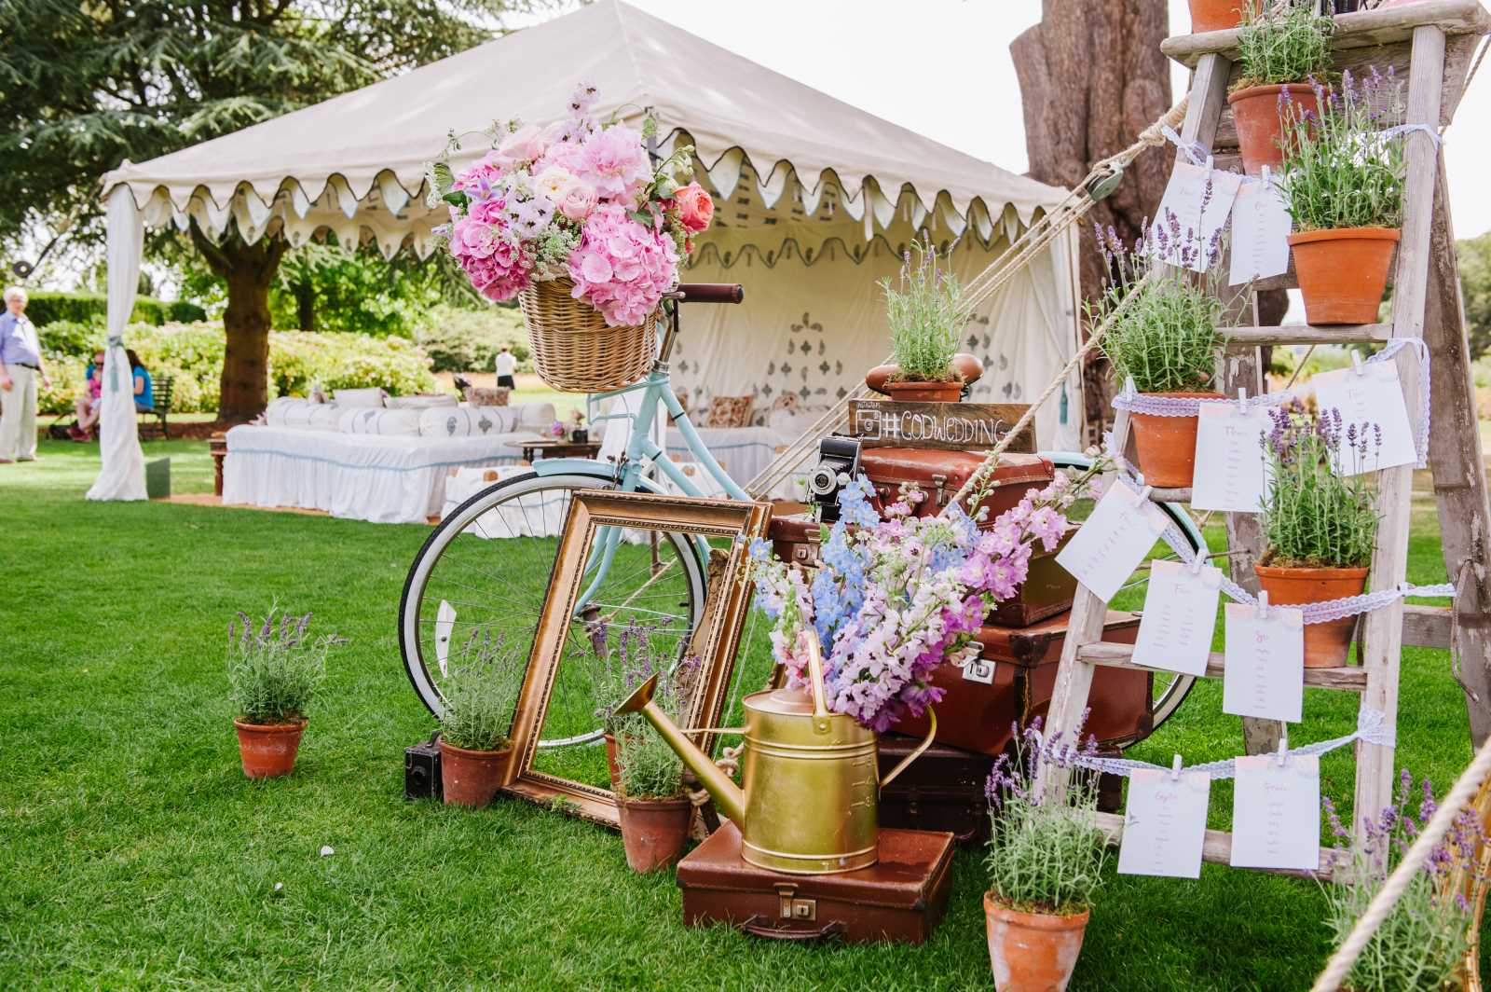

**Invites you to**

**Clanfield Residential Home**

**Our Garden Party…**

**Come & join us!**

**Saturday 15 June 2024**

**Between 2pm and 5pm.**



